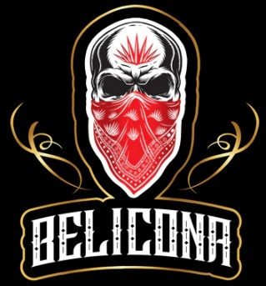

INVENTARIO BELICONA SABORES POLANCO

|  |  |
| --- | --- |
| LATAS BELICONA 355 ML |  |
| STAND | 1 Pzas |
| FRIGOBAR | 1 Pzas |
| BANDERAS | 2 Pzas |
| VINILES | 3 Pzas |